Operation Instructions

All experiments were performed at room temperature, under quasi-static loading conditions. Prior to each test the system was inspected to ensure correct electrical connections, mechanical alignment and proper communication between hardware and software components. Also, the load cell was calibrated using known reference loads to establish the voltage-to-force conversion. Before performing the test, the sample was marked with a pattern of dots aligned and parallels to its geometric center, as shown in Fig. 1. The macro camera was positioned at an inclination angle between 10° and 20° relative to the sample surface to ensure an adequate field of view, while the micro camera was positioned perpendicular to the sample. Both cameras were connected to the acquisition computer using USB 3.0 connections. Camera focus and illumination were adjusted manually before starting each test.

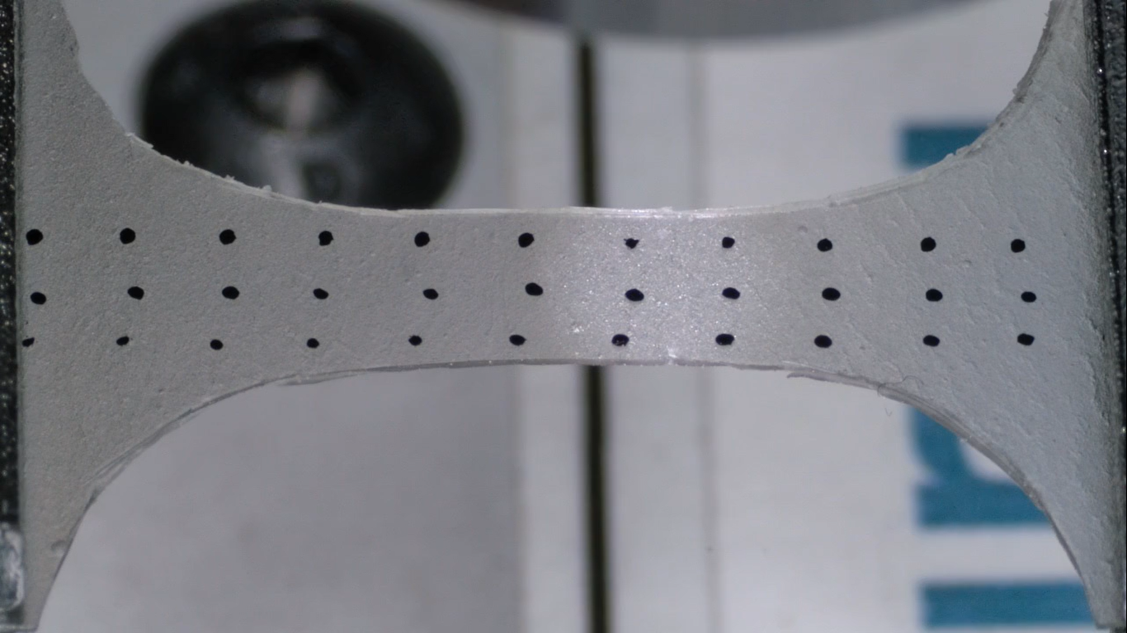
Fig. 1. Dot pattern on Cornstarch Biopolymer.

The linear actuation system consisted of a lead screw with a pitch of 5 mm/rev, driven by a closed-loop NEMA 23 servo/stepper motor controlled through a T60 driver configured at 40000 microsteps. Under this configuration, a pulse frequency of 300 Hz resulted in a displacement rate of approximately 0.05 mm/s, ensuring quasi-static loading conditions.

Force measurements were acquired using a load cell and connected to an Arduino Nano microcontroller. Motor control signals were generated by an Arduino Uno, which outputs a pulse wide modulated signal with configurable frequency through PWM pins. Both microcontrollers communicated with the acquisition computer through serial communication at a baud rate of 115200.

Operational Sequence

- The sample was mounted and aligned between the grips.
- The cameras were focused and aligned according to the macro and micro configurations, using the proprietary software provided by the camera manufacturer.
- The Python acquisition software was launched, establishing serial communication with both Arduino boards. The region of interest (ROI) corresponding to the sample area to be tracked was manually selected.
- Force data and image frames were acquired synchronously during the loading process. If pausing the experiment is required, the “p” key is pressed to temporarily halt data acquisition. The experiment is resumed by pressing the same key. The experiment is terminated manually by pressing the “q” key once the desired deformation level or failure condition is reached.
Image acquisition was performed using OpenCV. In post-processing mode, each captured frame was associated with a corresponding force measurement. In real-time mode, characteristic points were detected using the ORB algorithm, and frame-to-frame feature matching was performed. Force data and associated displacement measurements were stored in spreadsheet format using OpenPyXL. Image frames from both cameras were saved to disk during acquisition. After completion of the experiment, video files were generated from the recorded frames using FFmpeg via terminal commands.

